**Table of Contents**

1. Abstract
2. Introduction
3. Carbon Flux and Its Importance
4. Stokes Law and Predicting Sinking Speeds  
   A. Global Maps of Important Environmental Variables that are measured by satellite (T, S, μ)  
   B. Particle Size and Sinking Speed Estimates  
   C. Particle Size Distribution and Global Carbon Flux Estimates
5. Sediment Trap Data
6. Comparisons Between Data
7. Discussion
8. Citations

**Abstract**

The abstract will outline the essential topics of the thesis and condense it into a short and digestible package.

**Introduction**

The introduction will give background to the paper, reference relevant papers (Kostadinov et. al 2009, 2016, MIT Seawater Papers, Mouw Dataset), as well as stating the main points of the thesis: The mathematical concepts of Stokes Law (force balance between gravity and the friction of the fluid), satellite data and its resulting plots, comparisons sediment trap data. It will also outline the general structure for the paper.

**Carbon Flux and Its Importance**

**Stokes Law and Predicting Sinking Speeds**

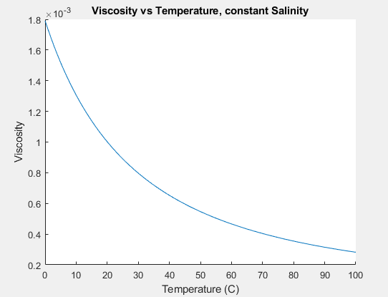

**(viscosityplot.m)**

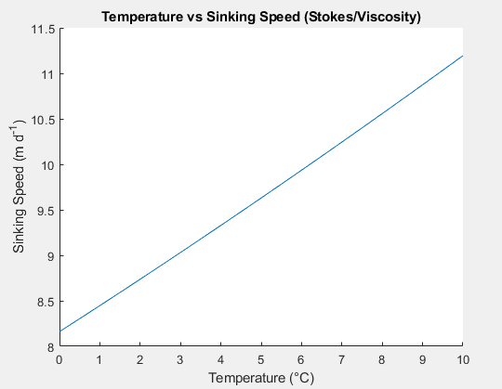

**(SpeedPlot_Viscosity_Density_Temperature.m)**

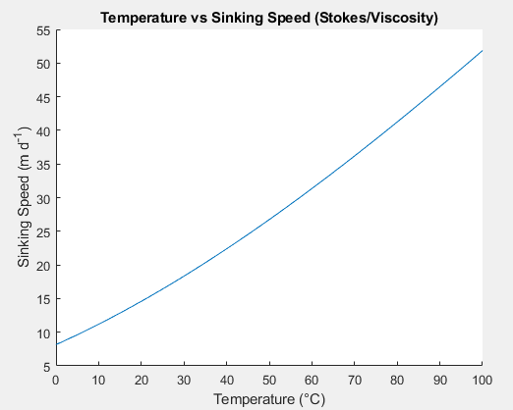

**(SpeedPlot_Viscosity_Density_Temperature.m)**

1. Global Maps of Important Environmental Variables that are measured by satellite (T, S, μ)

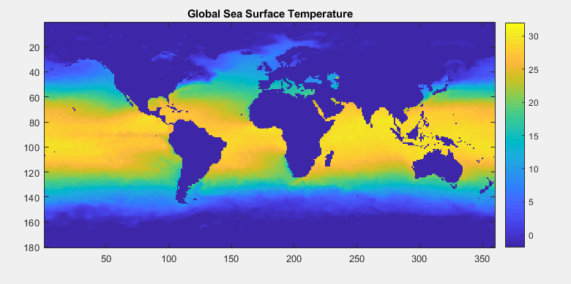

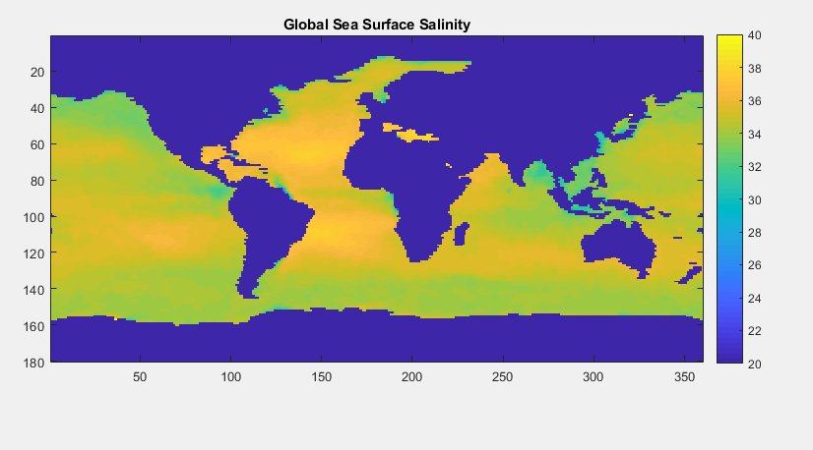

(C_biomass.m)

B. Particle Size and Sinking Speed

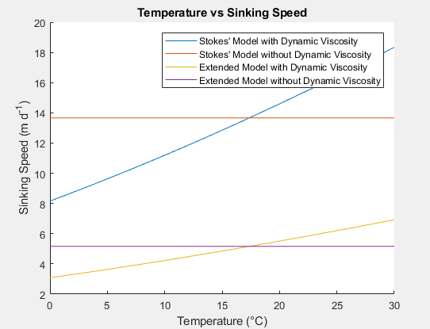

**(StokesDennysPlot.m)**

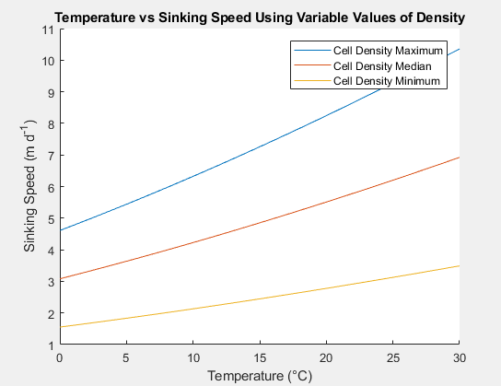

**(VariableDensity.m)**

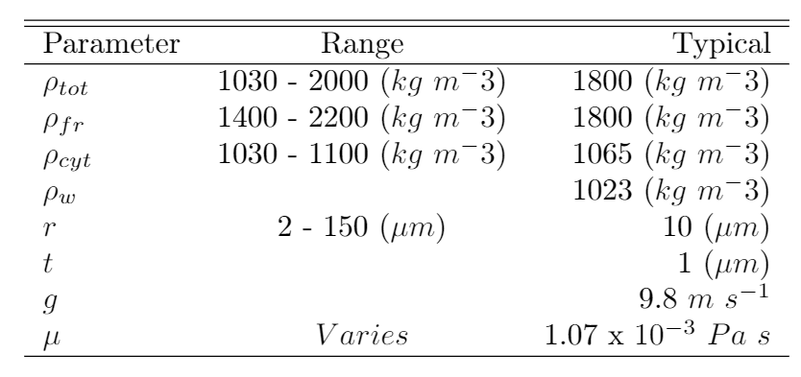

**(Mikalsz and Denny)**

C. Particle Size Distribution and Global Carbon Flux Estimates

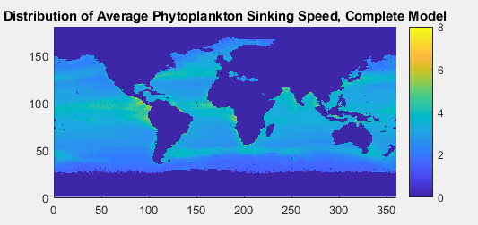

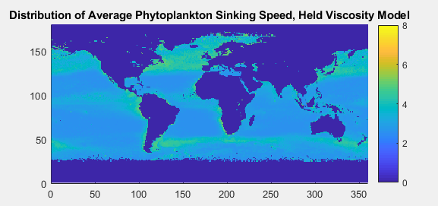

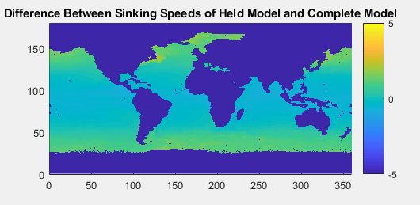

(SinkingSpeedScriptComplete.m)

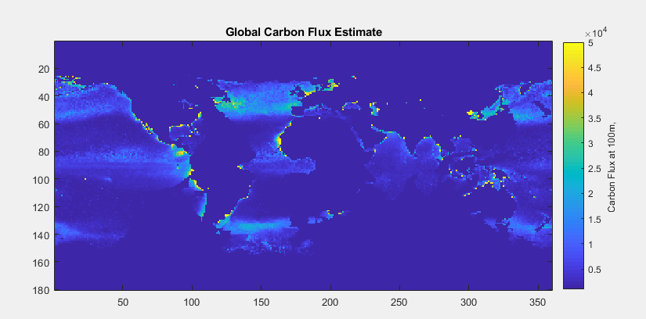

(C_Biomass.m)

**Sediment Trap Data**

**Comparisons Between Data**

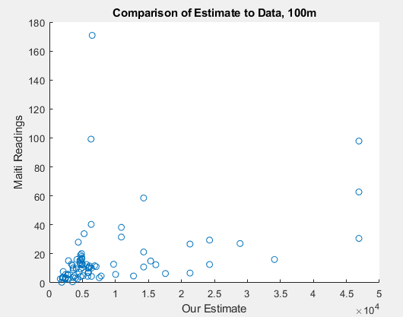

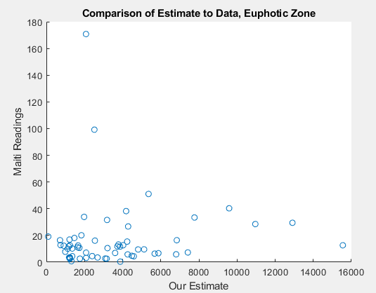

(C_biomass.m)

**Discussion**

**Citations**

Kostadinov, T. S., Siegel, D. A., & Maritorena, S. (2009). Retrieval of the particle size distribution from satellite ocean color observations. Journal of Geophysical Research, 114(C9). <https://doi.org/10.1029/2009jc005303>

Kostadinov, T. S., Milutinovic, S., Marinov, I., & Cabré, A. (2016). Size-partitioned phytoplankton carbon concentrations retrieved from ocean color data, links to data in NetCDF format, supplement to: Kostadinov, Tihomir S; Milutinovic, Svetlana; Marinov, Irina; Cabré, Anna (2016): Carbon-based phytoplankton size classes retrieved via ocean color estimates of the particle size distribution. Ocean Science, 12(2), 561-575 [Data set]. PANGAEA - Data Publisher for Earth & Environmental Science. <https://doi.org/10.1594/pangaea.859005>

Nayar, K. G., Sharqawy, M. H., Banchik, L. D., & Lienhard V, J. H. (2016). Thermophysical properties of seawater: A review and new correlations that include pressure dependence. Desalination, 390, 1–24. <https://doi.org/10.1016/j.desal.2016.02.024>

Sharqawy, M. H., Lienhard V, J. H., Zubair, S. M. (2010). Thermophysical Properties of seawater: A review of existing correlations and data. Desalination and Water Treatment, 16, 354-380.

<http://web.mit.edu/lienhard/www/Thermophysical_properties_of_seawater-DWT-16-354-2010.pdf>